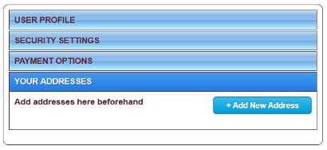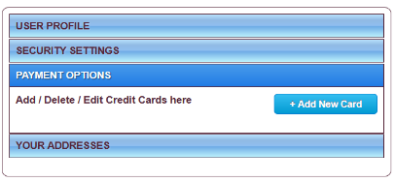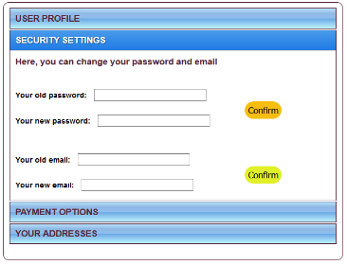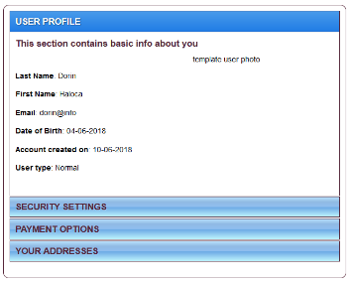

Modifi/Delete Address

Add New Address

MySQL

Database

Querry

Receive

**Controller.php**

**(Hashes password)**

Access

Your Adsresses

Modify/Delete Card Card

Add New Card

Access

Payment Options

Change password

Change email

Access

Security Settings

User Profile

Access

Front-end

Back-end